**PROJECT REPORT**

**On**

**BLOOD BANK AND DONOR MANAGEMENT**

**A PROJECT REPORT SUBMITTED**

**By**

**Madhav Mohan**

**University Roll No – 1802914006**

**Submitted in partial fulfillment of the**

**Requirements for the Degree of**

**MASTER OF COMPUTER APPLICATIONS**

**Under the Supervision of**

**Prof. Sangeeta Arora**

### ASSOCIATE PROFESSOR



**Submitted to**

**DR. APJ ABDUL KALAM TECHNICAL UNIVERSITY LUCKNOW**

**(Formerly Uttar Pradesh Technical University, Lucknow)**

**(JULY 2021)**

**DECLARATION**

I hereby declare that the work presented in this report entitled Blood Bank and Donor Management, was carried out by me. I have not submitted the matter embodied in this report for the award of any other degree or diploma of any other University or Institute.

I have given due credit to the original authors/sources for all the words, ideas, diagrams, graphics, computer programs, experiments, results, that are not my original contribution.  I have used quotation marks to identify verbatim sentences and given credit to the original authors/sources.

I affirm that no portion of my work is plagiarized, and the experiments and results reported in the report are not manipulated. In the event of a complaint of plagiarism and the manipulation of the experiments and results, I shall be fully responsible and answerable.

Name:  Madhav Mohan

Roll. No: 1802914006

Branch: MCA

(**Candidate Signature)**

CERTIFICATE

Certified that **Madhav Mohan (Enrollment No.1802914006)** has carried out the project work presented in this report entitled “**Blood Bank and Donor Management** “for the award of **Master of Computer Application** from Dr. A.P.J. Abdul Kalam Technical University, Lucknow under my supervision. The report embodies result of original work, and studies are carried out by the student himself and the contents of the report do not form the basis for the award of any other degree to the candidate or to anybody else from this or any other University.

**Dr. Sangeeta Arora External Examiner**

Associate Professor

Dept. of Computer Applications

KIET Group of Institutions, Ghaziabad

**Dr. Ajay Kumar Srivastava**

Professor & Head

Department of Computer Applications

KIET Group of Institutions, Ghaziabad

Date:

**ABSTRACT**

This project is a Web Application based resolve the user problem related to blood. The project objective is to find the solution of blood and provide the blood into web platform.

The process of managing the blood bag that is received from the blood donation events needs a proper and systematic management. The blood bag must be handled with care and treated thoroughly as it is related to someone’s life.

The development of Web-based Blood Bank Management System (BBMS) is proposed to provide a management functional to the blood bank to handle the blood bag.

Other hospital may have different ways and approach of handling blood bag. The methodology used to build this system uses the Rational Unified Process (RUP). The technology platform in implementing this system uses Python, HTML, CSS, JavaScript, and SQLite database and available.

**ACKNOWLEDGEMENT**

I take this occasion to thank God, almighty for blessing us with his grace and taking our endeavor to a successful culmination. I extend my sincere and heartfelt thanks to our esteemed guide, Prof. **Sangeeta Arora**, for providing me with the right guidance and advice at the crucial junctures and for showing me the right way. I extend my sincere thanks to our respected **Head of the department Mr. AJAY SHRIVASTAV**, for allowing us to use the facilities available. I would like to thank the other faculty members also, at this occasion. Last but not the least, I would like to thank my friends and family for the support and encouragement they have given me during our work.

**MADHAV MOHAN**

**TABLE OF CONTENTS**

|  |  |
| --- | --- |
| COVER PAGE | i |
| DECLARATION | ii |
| CERTIFICATE | iii |
| ABSTRACT | iv |
| ACKNOWLEDGEMENT | v |
| LIST OF TABLES | vi-vii |
| LIST OF FIGURES | viii |
|  |  |
|  |  |
| **1.** **CHAPTER: Introduction** | **1-3** |
| 1.1 Project Detail | 1 |
| 1.2 Purpose | 1 |
| 1.3 Objective | 2 |
| 1.4 Project Scope | 2 |
| 1.5 Hardware and Software Requirements | 3 |
| 1.5.1 Software Requirements | 3 |
| 1.5.2 Hardware Requirements | 3 |
|  |  |
| **2.** **CHAPTER: Technical Feasibility** | **4-7** |
| 2. 1 Technical feasibility | 4 |
| 2.2 Economical Feasibility | 5 |
| 2.3 Operational Feasibility | 5 |
| 2.4 Social and Behavioral Feasibility | 5 |
| 2.5 Legal Feasibility | 5 |
| 2.6 Technology Description | 6 |
| 2.6.1 Python | 6 |
| 2.6.2 HTML | 6 |
| 2.6.3 CSS | 6 |
| 2.6.4 Java Script | 7 |
| 2.6.5 Django | 7 |
|  |  |
| **3. CHAPTER: Backend Design** | **8-13** |
| 3.1 Use Case Diagram | 8 |
| 3.2 Sequence Diagram for Administration | 9 |
| 3.3 DFD | 10 |
| 3.3.1 zero level DFD | 11 |
| 3.3.2 first level DFD | 12 |
| 3.4 ER Diagram | 13 |
|  |  |
| **4. CHAPTER: Frontend Design** | **14-23** |
| Input / Output Form (Screenshot) |  |
|  |  |
| **5. CHAPTER: Report** | **24-48** |
| 5.1 Coding |  |
|  |  |
| **6. CHAPTER: Testing** | **49-50** |
| 6.1 Unit testing | 49 |
| 6.2 Integration testing | 50 |
| 6.3 System testing | 50 |
| 6.4 Acceptance testing | 50 |
|  |  |
| **7. CHAPTER: Limitation** | **51** |
| 7.1 Limitation | 51 |
| 7.2 Future Scope | 51 |
| 7.3 Future Enhancement | 51 |
|  |  |
| **8. CHAPTER: Conclusion** | **52** |
| **9. CHAPTER: Bibliography** | **53-54** |
|  |  |
|  |  |
|  |  |

# LIST OF FIGURES

|  |  |  |
| --- | --- | --- |
| **Fig No** | **Title** | **Page No** |
| 3.1 | Use Case Diagram | 15 |
| 3.2 | Sequence Diagram for Administration | 16 |
| 3.4.1 | Zero Level DFD | 18 |
| 3.4.2 | First Level DFD | 19 |
| 3.5 | ER Diagram | 12 |
| 4.1 | Home Page | 22 |
| 4.2 | Become a Donor Page | 23 |
| 4.3 | Search a Donor Page | 24 |
| 4.4 | Contact us Page | 25 |
| 4.5 | Admin Login Page | 26 |
| 4.6 | Admin Dashboard Page | 27 |
| 4.7 | Add Blood group Page | 28 |
| 4.8 | Manage Blood group Page | 29 |
| 4.9 | Add Donor Page | 30 |

CHAPTER 1

INTRODUCTION

Blood Bank and Donor Management system is a web-based application on Python language and SQLite database. The purpose of this project was to develop a blood donor management information system to assist in the management of blood donor records and blood group records. And this project also helpful for searching blood donor according to location and blood group. This project includes mainly two modules i.e., admin and visitor.

The current system is manual, and it is time-consuming. It is also cost-ineffective, and the average return is low and diminishing.

**1.1 Project Detail**

The main goal of the Blood Bank and Donor Management System project is to monitor Blood Bank data, Blood cells, Blood stock, Donor List. It manages all the Blood Bank, Donor, Blood stock data. The project is entirely administrative and therefore access is guaranteed only to the administrator.

**1.2 Purpose**

* The purpose of the blood bank management system is tosimplify and automate the process of searching for blood in case of emergency and maintain the records of blood donors, recipients, blood donation programs and blood stocks in the bank.
* The project is basically targeted at those people who would like online management software.
* To make a database that is consistent, reliable, and secure.
* To provide correct, complete, and ongoing information.
* To develop a well-organized information storage system.
* To make good documentation to facilitate possible future enhancements.

**1.3 Objective**

* An easy way to search the nearest blood banks to the accident site with the help of GPS.
* An effective way to find out the availability of the required blood groups in the blood banks.
* A proficient way to search the volunteer blood donors. • Providing tips regarding the necessary measures that are to be taken before the blood donation

**1.4 Project Scope**

The project has a wide scope, as it is not intended to a particular organization. This project is going to develop generic software, which can be applied by any business’s organization. Moreover, it provides facility to its users. Also, the software is going to provide a huge amount of summary data.

**1.5 Hardware and Software Requirements**

**1.5.1 Software Requirements:**

* + Technology: Python Django
  + IDE: PyCharm/Atom
  + Client-Side Technologies: HTML, CSS, JavaScript, Bootstrap
  + Server-Side Technologies: Python
  + Data Base Server: SQLite
  + Operating System: Microsoft Windows/Linux

**1.5.2 Hardware Requirements:**

* + Processor: Pentium-III (or) Higher
  + Ram: 64MB (or) Higher
  + Hard disk: 80GB (or) Higher

CHAPTER 2

FEASIBILITY STUDY

The feasibility study is performed to determine whether the proposed system is viable considering the Technical, Operational and Economical factors. After going through feasibility Study, we can have a clear-cut view of the system’s benefits and drawbacks.

Why Do I Need a Feasibility Study?

Feasibility studies are important for a communications service provider to determine whether your broadband project will succeed or not. It should be the first action taken when wanting to begin a new project. It is one, if not the most important factor in determining whether the project can and should move forward. Also, if you are applying for broadband loans and grants, a feasibility study is normally required.

2.1 Technical Feasibility

Technical feasibility evaluates the technical complexity of the expert system and often involves determining whether the expert system can be implemented with state-of-the-art techniques and tools. In the case of expert systems, an important aspect of technical feasibility is determining the shell in which the system will be developed. The shell used to develop an expert system can be an important determinant to its quality and makes it vital to the system's success. Although the desirable characteristics of an expert system shell will depend on the task and domain requirements, the shell must be flexible enough to build expert reasoning into the system effectively. It must also be easily integrated with existing computer-based systems. Furthermore, a shell providing a user-friendly interface encourages end users to use the system more frequently.

2.2 ECONOMICAL FEASIBILITY

It deals with question related to the economy. It comprises of the following questions: -

* Are there sufficient benefits in creating the system to make the cost acceptable?
* Are the costs of not creating the system so great that the project must be undertaken?

Development of this application is highly economically feasible. The organization needed not spend much money for the development of the system already available. The only thing is to be done is making an environment for the development with an effective supervision. Even after the development, the organization will not be in condition to invest more in the organization.

2.3 OPERATIONAL FEASIBILITY

The operational feasibility consists of the following activity: -

* + - * Will the system be useful if it is developed &implemented?

2.4 SOCIAL AND BEHAVIORAL FEASIBILITY

It deals with the various issues related to the human behavior like: -

* + - * Whether the user be able to adapt a new change or not?
      * Whether the ambiance we are providing suits the user or not?

2.5 LEGAL FEASIBILITY

It deals with the question related to the legal issues. It comprises of the following questions: -

* Contract Signing
* Software License agreement
  + - * Issues related to cyber laws.
      * Legal issues relating to the manpower contract.

2.6 Technology Description

2.6.1 Python

Python is a widely used general-purpose, high level programming language. It was initially designed by Guido van Rossum in 1991 and developed by Python Software Foundation. It was mainly developed for emphasis on code readability, and its syntax allows programmers to express concepts in fewer lines of code.

Python is a programming language that lets you work quickly and integrate systems more efficiently.

Python is dynamically typed, and garbage collected. It supports multiple programming paradigms, including procedural, object-oriented, and functional programming. Python is often described as a "batteries included" language due to its comprehensive standard library.

2.6.2 HTML

HTML (Hypertext Markup Language) is the set of markup symbols or codes inserted in a file intended for display on a World Wide Web browser page. The markup tells the Web browser how to display a Web page's words and images for the user. Each individual markup code is referred to as an element (but many people also refer to it as a tag). Some elements come in pairs that indicate when some display effect is to begin and when it is to end.

2.6.3 CASCADING STYLE SHEET (CSS)

Cascading Style Sheets (CSS) are a collection of rules we use to define and modify web pages. CSS are like styles in Word. CSS allow Web designers to have much more control over their pages look and layout. For instance, you could create a style that defines the body text to be Verdana, 10 points. Later, you may easily change the body text to Times New Roman, 12 points by just changing the rule in the CSS. Instead of having to change the font on each page of your website, all you need to do is redefine the style on the style sheet, and it will instantly change on all the pages that the style sheet has been applied to. With HTML styles, the font change would be applied to each instance of that font and must be changed in each spot.

CSS can control the placement of text and objects on your pages as well as the look of those objects.

HTML information creates the objects (or gives objects meaning), but styles describe how the objects should appear. The HTML gives your page structure, while the CSS creates the “presentation”. An external CSS is just a text file with a .CSS extension. These files can be created with Dreamweaver, a CSS editor, or even Notepad.

2.64 JavaScript

JavaScript is a programming language commonly used in web development. It was originally developed by Netscape to add dynamic and interactive elements to websites. While JavaScript is influenced by Java, the syntax is more like C and is based on ECMAScript, a scripting language developed by Sun Microsystems.

JavaScript is a client-side scripting language, which means the source code is processed by the client's web browser rather than on the web server. This means JavaScript functions can run after a webpage has loaded without COMMUNICATING with the server. For example, a JavaScript function may check a web form before it is submitted to make sure all the required fields have been filled out. The JavaScript code can produce an error message before any information is transmitted to the server.

Like server-side scripting languages, such as PHP and ASP, JavaScript code can be inserted anywhere within the HTML of a webpage. However, only the output of server-side code is displayed in the HTML, while JavaScript code remains fully visible in the source of the webpage. It can also be referenced in a separate .JS file, which may also be viewed in a browser.

2.5 Django

Django is a web application framework written in Python programming language. It is based on MVT (Model View Template) design pattern. The Django is very demanding due to its rapid development feature. It takes less time to build application after collecting client requirement.

CHAPTER 3

BACKEND DESIGN

3.1 Use Case Diagram

* Use case diagram consists of use cases and actors and shows the interaction between them. The key points are:
* The main purpose is to show the interaction between the use cases and the actor.
* To represent the system requirement from user’s perspective.
* The use cases are the functions that are to be performed in the module.

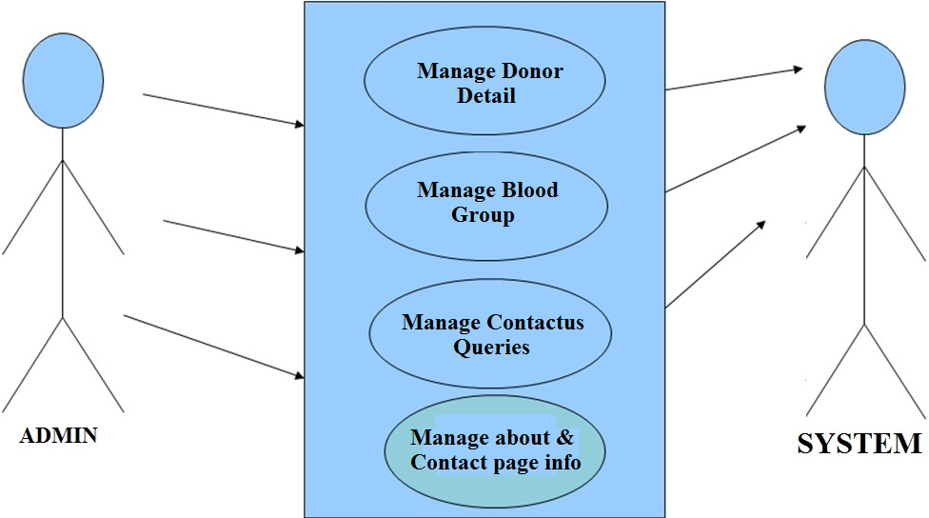

**Fig. 3.1 Use Case Diagram b/w admin and system**

3.2 Sequence Diagram for Administration

Text BoxText Box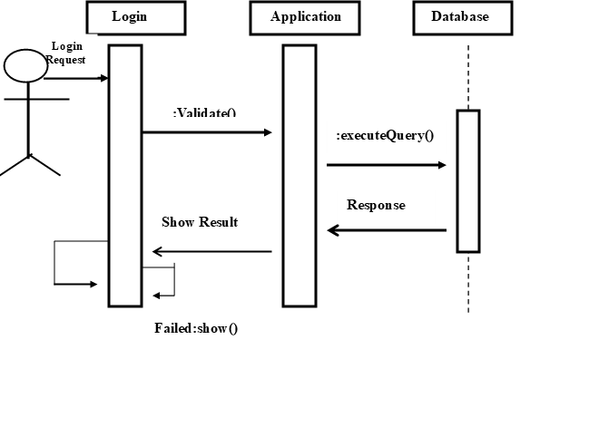

**Fig .3.2 Sequence Diagram**

3.3 Data Flow Diagram

A Data Flow Diagram (DFD) is a graphical representation of the "flow" of data through an Information System. A data flow diagram can also be used for the visualization of Data Processing. It is common practice for a designer to draw a context-level DFD first which shows the interaction between the system and outside entities. This context-level DFD is then "exploded" to show more detail of the system being modeled.

A DFD represents flow of data through a system. Data flow diagrams are commonly used during problem analysis. It views a system as a function that transforms the input into desired output. A DFD shows movement of data through the different transformations or processes in the system.

Dataflow diagrams can be used to provide the end user with a physical idea of where the data they input ultimately has an effect upon the structure of the whole system from order to dispatch to restock how any system is developed can be determined through a dataflow diagram. The appropriate register saved in database and maintained by appropriate authorities.

Data Flow Diagram Notation

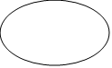

Function

Shape

ShapeShapeFile/Database

Shape

Input/output

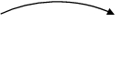Flow

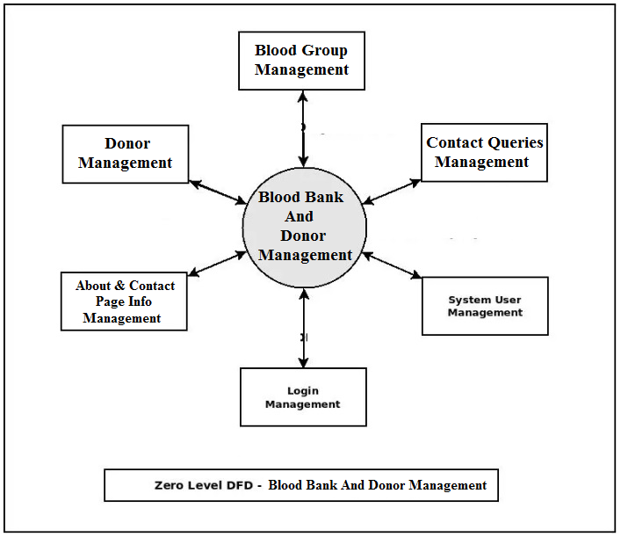

**Fig 3.3.1 Zero Level DFD**

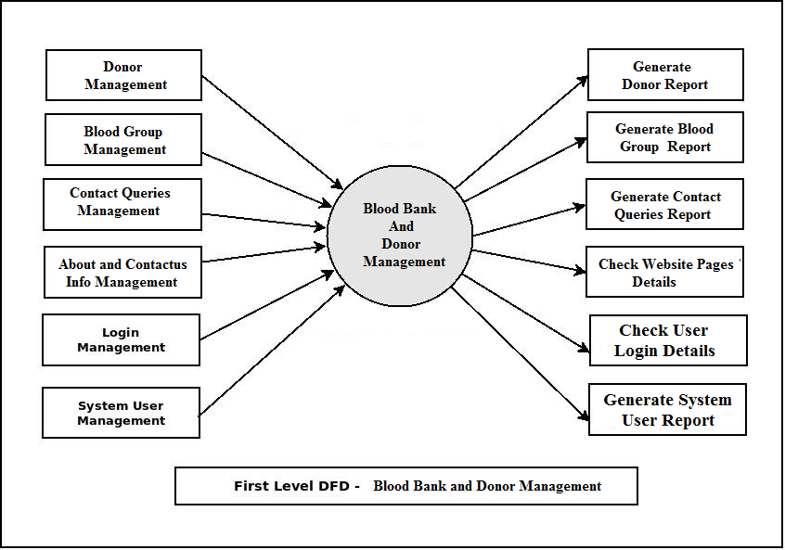

**Fig 3.3.2 First Level DFD**

3.4 ER Diagram

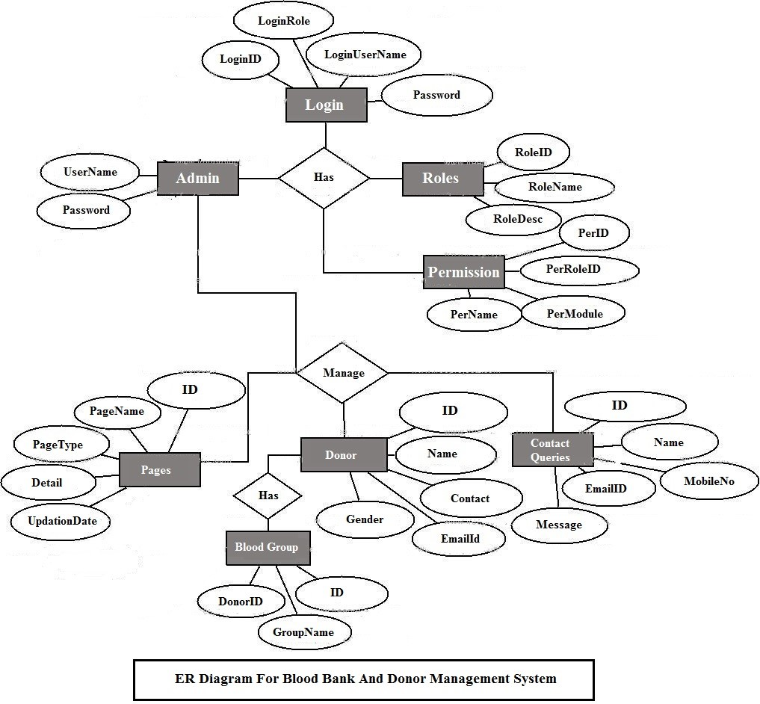

**Fig 3.4 ER Diagram**

CHAPTER 4

FRONTEND DESIGN

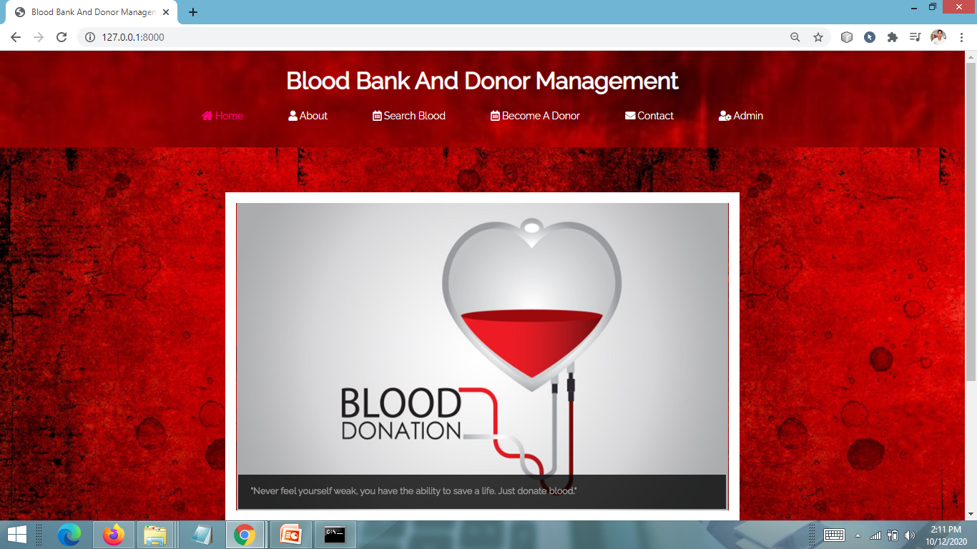

**Fig 4.1 HOME PAGE**

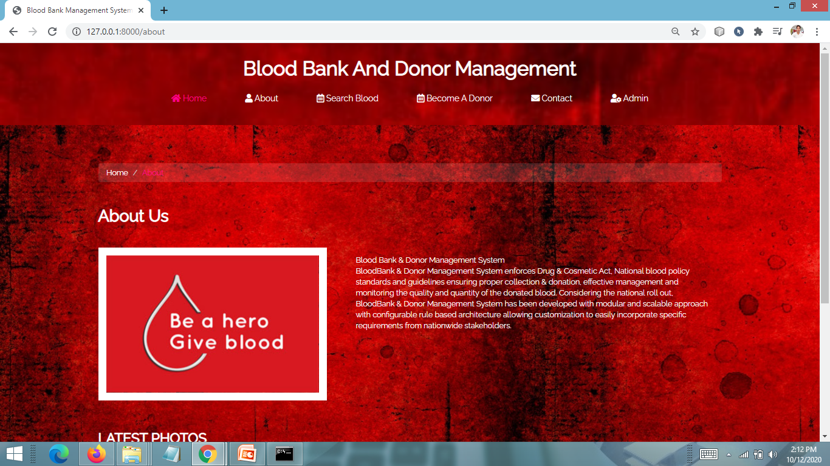

**Fig 4.2 Become a Donor Page**

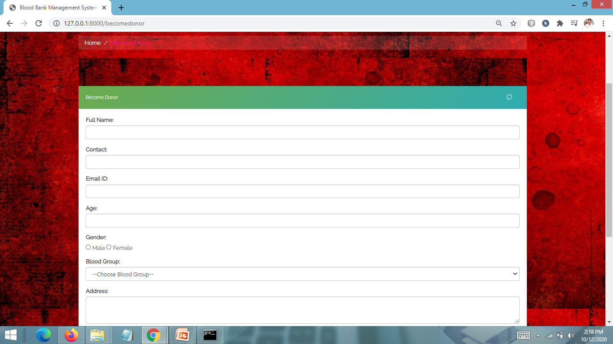

**Fig 4.3 SEARCH DONOR PAGE**

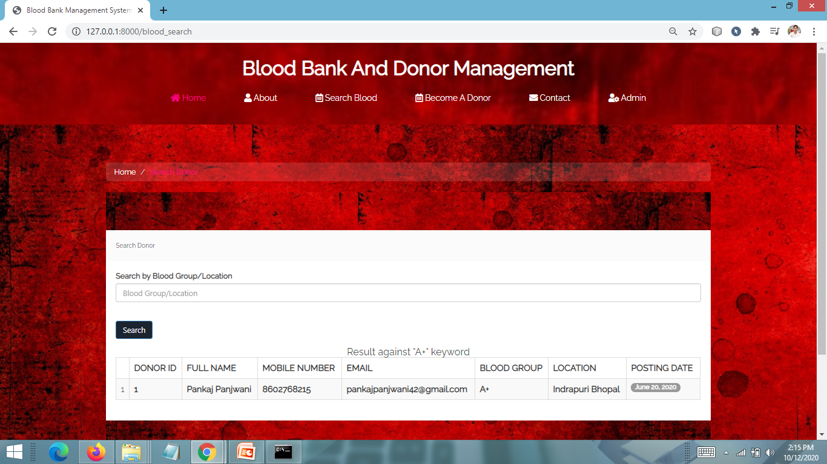 **Fig 4.4 CONTACT US PAGE**

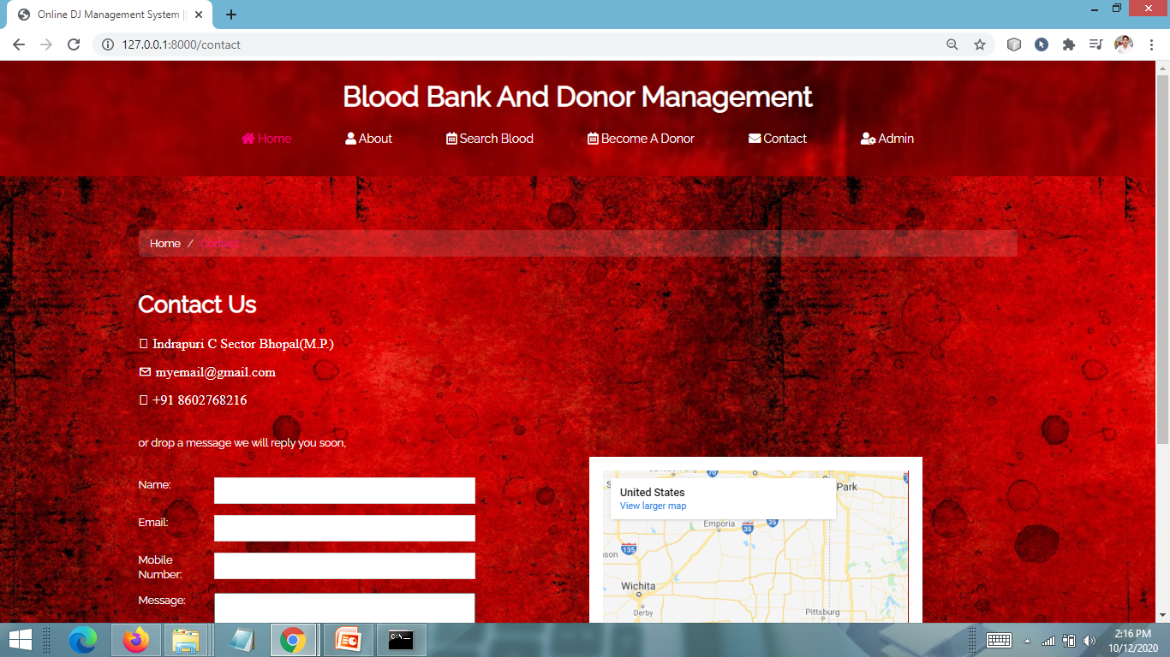

**Fig 4.5 ADMIN LOGIN PAGE**

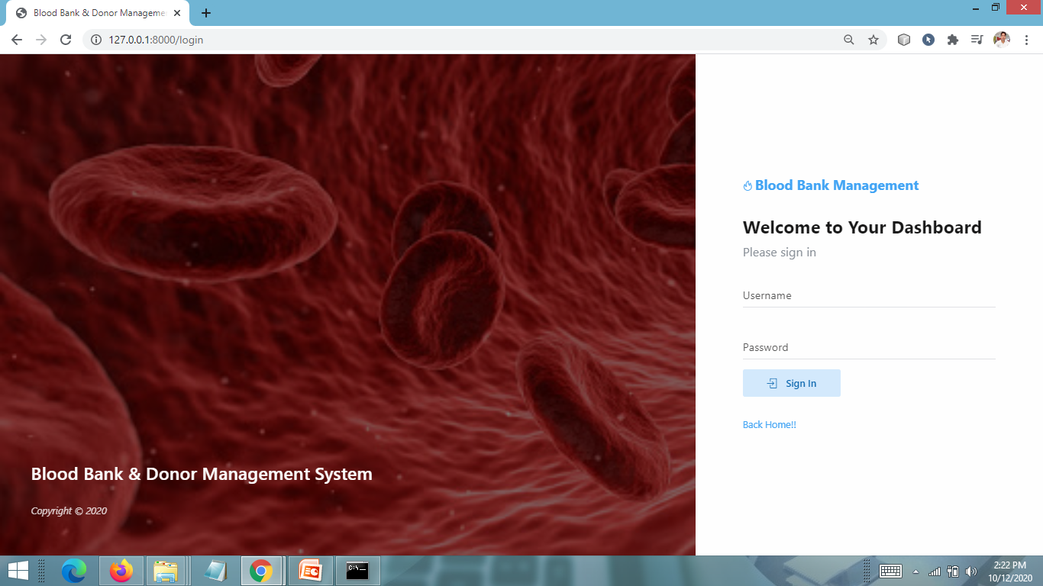

**Fig 4.6 ADMIN DASHBOARD PAGE**

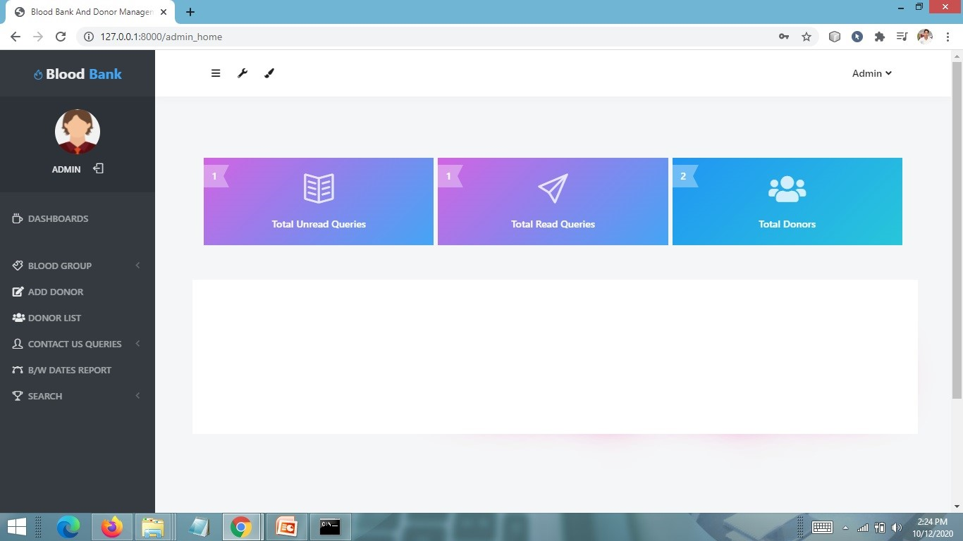

**Fig 4.7 ADD BLOODGROUP PAGE**

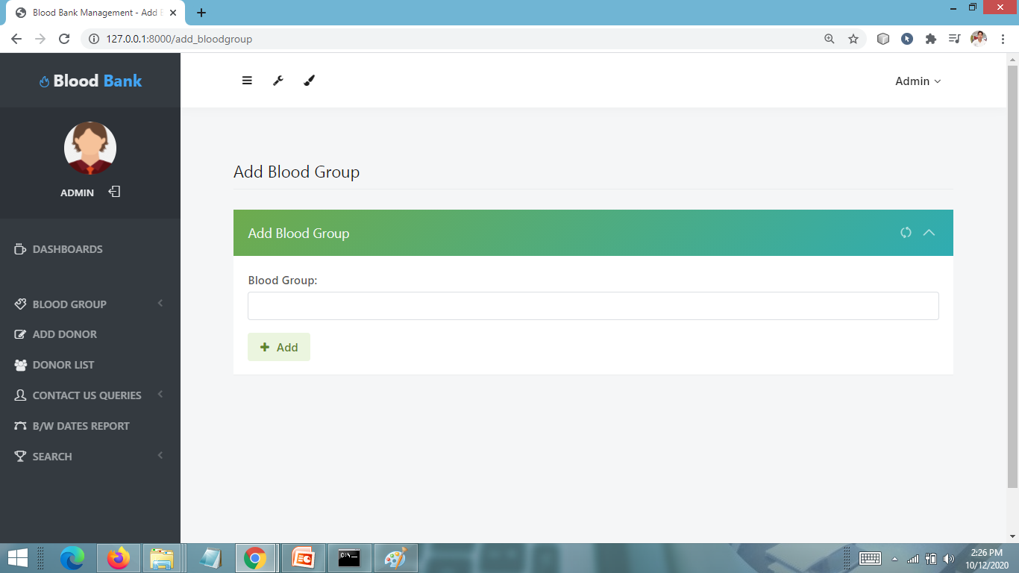

**Fig 4.8 MANAGE BLOOD GROUP PAGE**

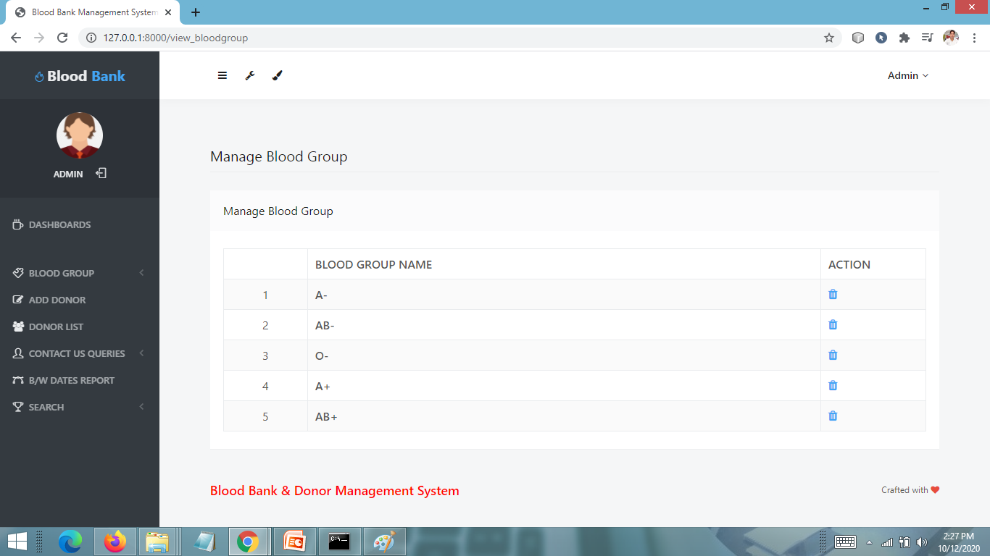

**Fig 4.9 ADD DONOR PAGE**

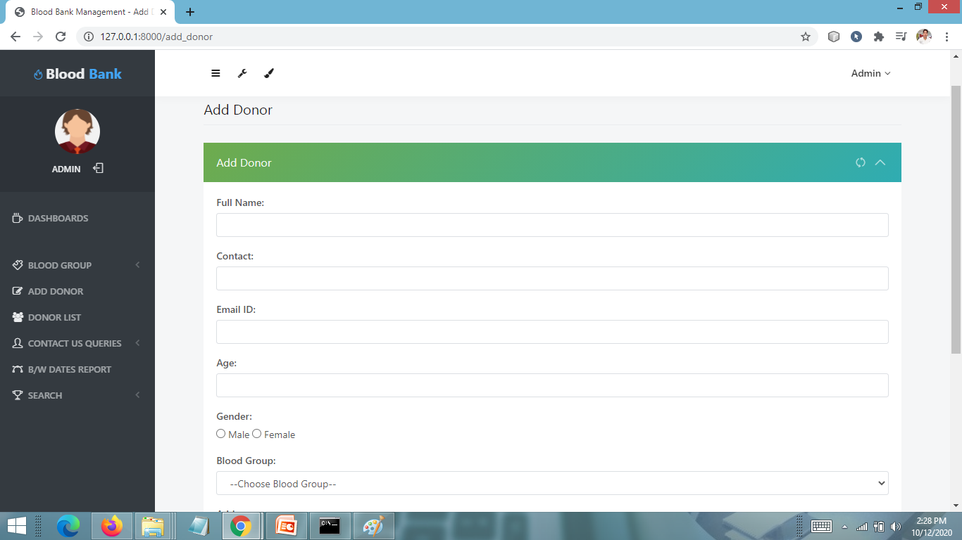

**Fig 4.10 VIEW DONOR LIST PAGE**

CHAPTER 3

REPORT

**HOME PAGE CODING**

**{% load static %}**

**{% block body %}**

**<html>**

**<head>**

**<title>Blood Bank And Donor Management ||Home Page</title>**

**<script src="{% static 'js/responsiveslides.min.js' %}"></script>**

**<link href="{% static 'css/bootstrap.css' %}" rel='stylesheet' type='text/css' />**

**<script src="{% static 'js/jquery.min.js' %}"></script>**

**<!-- jQuery (Bootstrap's JavaScript plugins) -->**

**<script type="application/x-javascript"> addEventListener("load", function() { setTimeout(hideURLbar, 0); }, false); function hideURLbar(){ window.scrollTo(0,1); } </script>**

**<!-- Custom Theme files -->**

**<link rel="stylesheet" href="{% static 'css/style.css' %}" type="text/css" media="all">**

**<link href='http://fonts.googleapis.com/css?family=Monoton' rel='stylesheet' type='text/css'>**

**<link href='http://fonts.googleapis.com/css?family=Raleway' rel='stylesheet' type='text/css'>**

**</head>**

**<body>**

**<!---->**

**{% include 'navigationbar.html' %}**

**<!---->**

**<script src="{% static 'js/responsiveslides.min.js' %}"></script>**

**<script>**

**// You can also use "$(window).load(function() {"**

**$(function () {**

**$("#slider").responsiveSlides({**

**auto: true,**

**manualControls: '#slider3-pager',**

**});**

**});**

**</script>**

**<div class="content">**

**<div class="container">**

**<div class="slider">**

**<!-- Slideshow 3 -->**

**<ul class="rslides" id="slider">**

**<li><img src="{% static 'images/7.jpg' %}" alt="">**

**<div class="caption">**

**<h1>"Bring a life back to power. Make blood donation your responsibility"</h1>**

**</div>**

**</li>**

**<li><img src="{% static 'images/2.jpg' %}" alt="">**

**<div class="caption">**

**<h1>"Anybody can give blood"</h1>**

**</div>**

**</li>**

**<li><img src="{% static 'images/10.jpg' %}" alt="">**

**<div class="caption">**

**<h1>"Donate your blood for a reason, let the reason to be life"</h1>**

**</div>**

**</li>**

**<li><img src="{% static 'images/5.jpg' %}" alt="">**

**<div class="caption">**

**<h1>"Starve a vampire, donate blood"</h1>**

**</div>**

**</li>**

**<li><img src="{% static 'images/8.jpg' %}" alt="">**

**<div class="caption">**

**<h1>"Don't let mosquitoes get your blood first"</h1>**

**</div>**

**</li>**

**<li><img src="{% static 'images/1.jpg' %}" alt="">**

**<div class="caption">**

**<h1>"I have nothing to offer but blood, toil, tears and sweat."</h1>**

**</div>**

**</li>**

**<li><img src="{% static 'images/13.jpg' %}" alt="">**

**<div class="caption">**

**<h1>"Never feel yourself weak, you have the ability to save a life. Just donate blood."</h1>**

**</div>**

**</li>**

**<li><img src="{% static 'images/3.jpg' %}" alt="">**

**<div class="caption">**

**<h1>"You are Rock Star in someone’s life, donate blood."</h1>**

**</div>**

**</li>**

**</ul>**

**<!-- Slideshow 3 Pager --></br></br>**

**<ul id="slider3-pager">**

**<li><a href="#"><img src="{% static 'images/77.jpg' %}" alt=""></a></li>**

**<li><a href="#"><img src="{% static 'images/22.jpg' %}" alt=""></a></li>**

**<li><a href="#"><img src="{% static 'images/1010.jpg' %}" alt=""></a></li>**

**<li><a href="#"><img src="{% static 'images/55.jpg' %}" alt=""></a></li>**

**<li><a href="#"><img src="{% static 'images/88.jpg' %}" alt=""></a></li>**

**<li><a href="#"><img src="{% static 'images/11.jpg' %}" alt=""></a></li>**

**<li><a href="#"><img src="{% static 'images/1313.jpg' %}" alt=""></a></li>**

**<li><a href="#"><img src="{% static 'images/33.jpg' %}" alt=""></a></li>**

**</ul>**

**<div class="clearfix"></div>**

**</div>**

**</div>**

**{% include 'footer.html' %}**

**</div>**

**<!---->**

**<!---->**

**</body>**

**</html>**

**{% endblock %}**

**SEARCH DONOR PAGE CODING**

**{% load static %}**

**{% block body %}**

**<html>**

**<head>**

**<title>Blood Bank Management System || Search Donor</title>**

**<link rel="stylesheet" id="css-main" href="{% static 'adminassets/css/codebase.min.css' %}">**

**<link href="{% static 'css/bootstrap.css' %}" rel='stylesheet' type='text/css' />**

**<script src="{% static 'js/jquery.min.js' %}"></script>**

**<link rel="stylesheet" href="{% static 'css/style.css' %}" type="text/css" media="all">**

**<!-- Custom Theme files -->**

**<link rel="stylesheet" href="{% static 'css/touchTouch.css' %}" type="text/css" media="all" />**

**<!-- Custom Theme files -->**

**<script type="application/x-javascript"> addEventListener("load", function() { setTimeout(hideURLbar, 0); }, false); function hideURLbar(){ window.scrollTo(0,1); } </script>**

**<!--webfont-->**

**<link href='http://fonts.googleapis.com/css?family=Monoton' rel='stylesheet' type='text/css'>**

**<link href='http://fonts.googleapis.com/css?family=Raleway' rel='stylesheet' type='text/css'>**

**<!---//End-css-style-switecher----->**

**<script type="text/javascript" src="{% static 'js/jquery.fancybox.js' %}"></script>**

**<link rel="stylesheet" type="text/css" href="{% static 'css/jquery.fancybox.css' %}" media="screen" />**

**<script type="text/javascript">**

**$(document).ready(function() {**

**/\***

**\* Simple image gallery. Uses default settings**

**\*/**

**$('.fancybox').fancybox();**

**});**

**</script>**

**</head>**

**<body>**

**<!---->**

**{% include 'navigationbar.html' %}**

**<div class="about content">**

**<div class="container">**

**<ol class="breadcrumb">**

**<li><a href="{% url 'home' %}">Home</a></li>**

**<li class="active">Search Donor</li>**

**</ol>**

**<!-- Main Container -->**

**<main id="main-container">**

**<!-- Page Content -->**

**<div class="content">**

**<!-- Dynamic Table Full Pagination -->**

**<div class="block">**

**<div class="block-header block-header-default">**

**<h3 class="block-title">Search Donor</h3>**

**</div>**

**<div class="block-content block-content-full">**

**<!-- DataTables init on table by adding .js-dataTable-full-pagination class, functionality initialized in js/pages/be_tables_datatables.js -->**

**<form id="basic-form" method="post">**

**{% csrf_token %}**

**<div class="form-group">**

**<label>Search by Blood Group/Location</label>**

**<input id="searchdata" type="text" name="searchblood" required="true" class="form-control" placeholder="Blood Group/Location"></div>**

**<br>**

**<button type="submit" class="btn btn-primary" name="search" id="submit">Search</button>**

**</form>**

**{% ifequal terror "found" %}**

**<h4 align="center">Result against "{{ sd }}" keyword </h4>**

**<table class="table table-bordered table-striped table-vcenter js-dataTable-full-pagination">**

**<thead>**

**<tr>**

**<th class="text-center"></th>**

**<th>Donor ID</th>**

**<th class="d-none d-sm-table-cell">Full Name</th>**

**<th class="d-none d-sm-table-cell">Mobile Number</th>**

**<th class="d-none d-sm-table-cell">Email</th>**

**<th class="d-none d-sm-table-cell">Blood Group</th>**

**<th class="d-none d-sm-table-cell">Location</th>**

**<th class="d-none d-sm-table-cell">Posting Date</th>**

**</tr>**

**</thead>**

**<tbody>**

**{% for i in donor %}**

**<tr>**

**<td class="text-center">{{forloop.counter}}</td>**

**<td class="font-w600">{{i.id}}</td>**

**<td class="font-w600">{{i.fullname}}</td>**

**<td class="font-w600">{{i.mobileno}}</td>**

**<td class="font-w600">{{i.emailid}}</td>**

**<td class="font-w600">{{i.group.bloodgroup}}</td>**

**<td class="font-w600">{{i.address}}</td>**

**<td class="font-w600">**

**<span class="badge badge-primary">{{i.postingdate}}</span>**

**</td>**

**</tr>**

**{% endfor %}**

**</tbody>**

**{% else %}**

**<tr>**

**<td colspan="8"> No record found against this search</td>**

**</tr>**

**{% endifequal %}**

**</table>**

**</div>**

**</div>**

**<!-- END Dynamic Table Full Pagination -->**

**<!-- END Dynamic Table Simple -->**

**</div>**

**<!-- END Page Content -->**

**</main>**

**<!-- END Main Container -->**

**{% include 'footer.html' %}**

**</div>**

**</div>**

**<!---->**

**<!---->**

**</body>**

**</html>**

**{% ifequal error "no" %}**

**<script>**

**alert('Record Saved Successfully');**

**</script>**

**{% endifequal %}**

**{% ifequal error "yes" %}**

**<script>**

**alert('Something went wrong , Try Again');**

**</script>**

**{% endifequal %}**

**{% endblock %}**

**DONAR REGISTRRATION PAGE CODING**

**{% load static %}**

**{% block body %}**

**<html>**

**<head>**

**<title>Blood Bank Management System || Become A Donor</title>**

**<link rel="stylesheet" id="css-main" href="{% static 'adminassets/css/codebase.min.css' %}">**

**<link href="{% static 'css/bootstrap.css' %}" rel='stylesheet' type='text/css' />**

**<script src="{% static 'js/jquery.min.js' %}"></script>**

**<link rel="stylesheet" href="{% static 'css/style.css' %}" type="text/css" media="all">**

**<!-- Custom Theme files -->**

**<link rel="stylesheet" href="{% static 'css/touchTouch.css' %}" type="text/css" media="all" />**

**<!-- Custom Theme files -->**

**<script type="application/x-javascript"> addEventListener("load", function() { setTimeout(hideURLbar, 0); }, false); function hideURLbar(){ window.scrollTo(0,1); } </script>**

**<!--webfont-->**

**<link href='http://fonts.googleapis.com/css?family=Monoton' rel='stylesheet' type='text/css'>**

**<link href='http://fonts.googleapis.com/css?family=Raleway' rel='stylesheet' type='text/css'>**

**<!---//End-css-style-switecher----->**

**<script type="text/javascript" src="{% static 'js/jquery.fancybox.js' %}"></script>**

**<link rel="stylesheet" type="text/css" href="{% static 'css/jquery.fancybox.css' %}" media="screen" />**

**<script type="text/javascript">**

**$(document).ready(function() {**

**/\***

**\* Simple image gallery. Uses default settings**

**\*/**

**$('.fancybox').fancybox();**

**});**

**</script>**

**</head>**

**<body>**

**<!---->**

**{% include 'navigationbar.html' %}**

**<div class="about content">**

**<div class="container">**

**<ol class="breadcrumb">**

**<li><a href="{% url 'home' %}">Home</a></li>**

**<li class="active">Become Donor</li>**

**</ol>**

**<!-- Main Container -->**

**<main id="main-container">**

**<!-- Page Content -->**

**<div class="content">**

**<!-- Register Forms -->**

**<div class="row">**

**<div class="col-md-12">**

**<!-- Bootstrap Register -->**

**<div class="block block-themed">**

**<div class="block-header bg-gd-emerald">**

**<h3 class="block-title">Become Donor</h3>**

**<div class="block-options">**

**<button type="button" class="btn-block-option" data-toggle="block-option" data-action="state_toggle" data-action-mode="demo">**

**<i class="si si-refresh"></i>**

**</button>**

**<button type="button" class="btn-block-option" data-toggle="block-option" data-action="content_toggle"></button>**

**</div>**

**</div>**

**<div class="block-content">**

**<form method="post">**

**{% csrf_token %}**

**<div class="form-group row">**

**<label class="col-12" >Full Name:</label>**

**<div class="col-12">**

**<input type="text" class="form-control" name="fullname" value="" required='true'>**

**</div>**

**</div>**

**<div class="form-group row">**

**<label class="col-12" >Contact:</label>**

**<div class="col-12">**

**<input type="text" class="form-control" name="contact" value="" required='true'>**

**</div>**

**</div>**

**<div class="form-group row">**

**<label class="col-12" >Email ID:</label>**

**<div class="col-12">**

**<input type="email" class="form-control" name="emailid" value="" required='true'>**

**</div>**

**</div>**

**<div class="form-group row">**

**<label class="col-12" >Age:</label>**

**<div class="col-12">**

**<input type="number" class="form-control" name="age" value="" required='true'>**

**</div>**

**</div>**

**<div class="form-group row">**

**<label class="col-12" >Gender:</label>**

**<div class="col-12">**

**<input type="radio" name="gender" value="male"> Male**

**<input type="radio" name="gender" value="male"> Female**

**</div>**

**</div>**

**<div class="form-group row">**

**<label class="col-12" >Blood Group:</label>**

**<div class="col-12">**

**<select type="text" class="form-control" name="bloodgroup" required="true" >**

**<option value="">--Choose Blood Group--</option>**

**{% for i in group %}**

**<option value="{{i.bloodgroup}}">{{i.bloodgroup}}</option>**

**{% endfor %}**

**</select>**

**</div>**

**</div>**

**<div class="form-group row">**

**<label class="col-12" >Address:</label>**

**<div class="col-12">**

**<textarea class="form-control" name="address" required='true'></textarea>**

**</div>**

**</div>**

**<div class="form-group row">**

**<label class="col-12" >Message:</label>**

**<div class="col-12">**

**<textarea class="form-control" name="message" required='true'></textarea>**

**</div>**

**</div>**

**<div class="form-group row">**

**<div class="col-12">**

**<button type="submit" class="btn btn-alt-success" name="submit">**

**<i class="fa fa-plus mr-5"></i> Add**

**</button>**

**</div>**

**</div>**

**</form>**

**</div>**

**</div>**

**<!-- END Bootstrap Register -->**

**</div>**

**</div>**

**</div>**

**<!-- END Page Content -->**

**</main>**

**<!-- END Main Container -->**

**{% include 'footer.html' %}**

**</div>**

**</div>**

**<!---->**

**<!---->**

**</body>**

**</html>**

**{% ifequal error "no" %}**

**<script>**

**alert('Record Saved Successfully');**

**</script>**

**{% endifequal %}**

**{% ifequal error "yes" %}**

**<script>**

**alert('Something went wrong , Try Again');**

**</script>**

**{% endifequal %}**

**{% endblock %}**

**ADMIN DASHBOARD PAGE CODING**

**{% load static %}**

**{% block body %}**

**<html lang="en" class="no-focus"> <!--<![endif]-->**

**<head>**

**<title>Blood Bank And Donor Management - Admin Dashboard</title>**

**<link rel="stylesheet" id="css-main" href="{% static 'adminassets/css/codebase.min.css' %}">**

**<link rel="stylesheet" href="https://use.fontawesome.com/releases/v5.7.0/css/all.css"**

**integrity="sha384-lZN37f5QGtY3VHgisS14W3ExzMWZxybE1SJSEsQp9S+oqd12jhcu+A56Ebc1zFSJ"**

**crossorigin="anonymous">**

**<style>**

**.glow {**

**font-size: 80px;**

**color: #fff;**

**text-align: center;**

**-webkit-animation: glow 1s ease-in-out infinite alternate;**

**-moz-animation: glow 1s ease-in-out infinite alternate;**

**animation: glow 1s ease-in-out infinite alternate;**

**}**

**@-webkit-keyframes glow {**

**from {**

**text-shadow: 0 0 10px #fff, 0 0 20px #fff, 0 0 30px #e60073, 0 0 40px #e60073, 0 0 50px #e60073, 0 0 60px #e60073, 0 0 70px #e60073;**

**}**

**to {**

**text-shadow: 0 0 20px #fff, 0 0 30px #ff4da6, 0 0 40px #ff4da6, 0 0 50px #ff4da6, 0 0 60px #ff4da6, 0 0 70px #ff4da6, 0 0 80px #ff4da6;**

**}**

**}**

**</style>**

**</head>**

**<body>**

**<div id="page-container" class="sidebar-o sidebar-inverse side-scroll page-header-fixed main-content-narrow">**

**{% include 'sidebar.html' %}**

**{% include 'admin_nav.html' %}**

**<!-- Main Container -->**

**<br><br><br>**

**<main id="main-container">**

**<!-- Page Content -->**

**<div class="content">**

**<div class="row gutters-tiny invisible" data-toggle="appear">**

**<!-- Row #1 -->**

**<div class="col-6 col-md-4 col-xl-4">**

**<a class="block text-center" href="{% url 'unread_queries' %}">**

**<div class="block-content ribbon ribbon-bookmark ribbon-crystal ribbon-left bg-gd-dusk">**

**<div class="ribbon-box">{{tuq}}</div>**

**<p class="mt-5">**

**<i class="si si-book-open fa-3x text-white-op"></i>**

**</p>**

**<p class="font-w600 text-white">Total Unread Queries</p>**

**</div>**

**</a>**

**</div>**

**<div class="col-6 col-md-4 col-xl-4">**

**<a class="block text-center" href="{% url 'read_queries' %}">**

**<div class="block-content ribbon ribbon-bookmark ribbon-crystal ribbon-left bg-gd-dusk">**

**<div class="ribbon-box">{{trq}}</div>**

**<p class="mt-5">**

**<i class="si si-paper-plane fa-3x text-white-op"></i>**

**</p>**

**<p class="font-w600 text-white">Total Read Queries</p>**

**</div>**

**</a>**

**</div>**

**<div class="col-6 col-md-4 col-xl-4">**

**<a class="block text-center" href="{% url 'donorlist' %}">**

**<div class="block-content ribbon ribbon-bookmark ribbon-crystal ribbon-left bg-gd-sea">**

**<div class="ribbon-box">{{td}}</div>**

**<p class="mt-5">**

**<i class="fa fa-users fa-3x text-white-op"></i>**

**</p>**

**<p class="font-w600 text-white">Total Donors</p>**

**</div>**

**</a>**

**</div>**

**<!-- END Row #1 -->**

**</div>**

**</div>**

**<!-- END Page Content -->**

**<br><br>**

**<footer class="site-footer mt-5">**

**<div class="container">**

**<div class="row text-center">**

**<div class="col-md-12">**

**<p style = "font-size : 30pt ; color : #FF0000 ; font-weight : bold">**

**Copyright &copy;<script>document.write(new Date().getFullYear());</script> All Rights Reserved <span style = "color : brown">|</span> <span style = "color : #006400">This website is made with <i class="fas fa-heart icon-heart text-warning" aria-hidden="true"></i> by </span><a class= "glow" href="#" target="_blank" >Pankaj Panjwani</a>**

**</p>**

**</div>**

**</div>**

**</div>**

**</footer>**

**</main>**

**<!-- END Main Container -->**

**{% include 'adminfooter.html' %}**

**</div>**

**<!-- END Page Container -->**

**<!-- Codebase Core JS -->**

**<script src="{% static 'adminassets/js/core/jquery.min.js' %}"></script>**

**<script src="{% static 'adminassets/js/core/popper.min.js' %}"></script>**

**<script src="{% static 'adminassets/js/core/bootstrap.min.js' %}"></script>**

**<script src="{% static 'adminassets/js/core/jquery.slimscroll.min.js' %}"></script>**

**<script src="{% static 'adminassets/js/core/jquery.scrollLock.min.js' %}"></script>**

**<script src="{% static 'adminassets/js/core/jquery.appear.min.js' %}"></script>**

**<script src="{% static 'adminassets/js/core/jquery.countTo.min.js' %}"></script>**

**<script src="{% static 'adminassets/js/core/js.cookie.min.js' %}"></script>**

**<script src="{% static 'adminassets/js/codebase.js' %}"></script>**

**<!-- Page JS Plugins -->**

**<script src="{% static 'adminassets/js/plugins/chartjs/Chart.bundle.min.js' %}"></script>**

**<!-- Page JS Code -->**

**<script src="{% static 'adminassets/js/pages/be_pages_dashboard.js' %}"></script>**

**</body>**

**</html>**

**{% endblock%}**

**ADD BLOOD GROUP PAGE CODING**

**{% load static %}**

**{% block body %}**

**<html lang="en" class="no-focus"> <!--<![endif]-->**

**<head>**

**<title>Blood Bank Management - Add Blood Group</title>**

**<link rel="stylesheet" id="css-main" href="{% static 'adminassets/css/codebase.min.css' %}">**

**</head>**

**<body>**

**<div id="page-container" class="sidebar-o sidebar-inverse side-scroll page-header-fixed main-content-narrow">**

**{% include 'sidebar.html' %}**

**{% include 'admin_nav.html' %}**

**<!-- Main Container -->**

**<main id="main-container">**

**<!-- Page Content -->**

**<div class="content">**

**<!-- Register Forms -->**

**<h2 class="content-heading">Add Blood Group</h2>**

**<div class="row">**

**<div class="col-md-12">**

**<!-- Bootstrap Register -->**

**<div class="block block-themed">**

**<div class="block-header bg-gd-emerald">**

**<h3 class="block-title">Add Blood Group</h3>**

**<div class="block-options">**

**<button type="button" class="btn-block-option" data-toggle="block-option" data-action="state_toggle" data-action-mode="demo">**

**<i class="si si-refresh"></i>**

**</button>**

**<button type="button" class="btn-block-option" data-toggle="block-option" data-action="content_toggle"></button>**

**</div>**

**</div>**

**<div class="block-content">**

**<form method="post">**

**{% csrf_token %}**

**<div class="form-group row">**

**<label class="col-12" >Blood Group:</label>**

**<div class="col-12">**

**<input type="text" class="form-control" name="bloodgroup" value="" required='true'>**

**</div>**

**</div>**

**<div class="form-group row">**

**<div class="col-12">**

**<button type="submit" class="btn btn-alt-success" name="submit">**

**<i class="fa fa-plus mr-5"></i> Add**

**</button>**

**</div>**

**</div>**

**</form>**

**</div>**

**</div>**

**<!-- END Bootstrap Register -->**

**</div>**

**</div>**

**</div>**

**<!-- END Page Content -->**

**</main>**

**<!-- END Main Container -->**

**{% include 'adminfooter.html' %}**

**</div>**

**<!-- END Page Container -->**

**<!-- Codebase Core JS -->**

**<script src="{% static 'adminassets/js/core/jquery.min.js' %}"></script>**

**<script src="{% static 'adminassets/js/core/popper.min.js' %}"></script>**

**<script src="{% static 'adminassets/js/core/bootstrap.min.js' %}"></script>**

**<script src="{% static 'adminassets/js/core/jquery.slimscroll.min.js' %}"></script>**

**<script src="{% static 'adminassets/js/core/jquery.scrollLock.min.js' %}"></script>**

**<script src="{% static 'adminassets/js/core/jquery.appear.min.js' %}"></script>**

**<script src="{% static 'adminassets/js/core/jquery.countTo.min.js' %}"></script>**

**<script src="{% static 'adminassets/js/core/js.cookie.min.js' %}"></script>**

**<script src="{% static 'adminassets/js/codebase.js' %}"></script>**

**</body>**

**</html>**

**{% ifequal error "no" %}**

**<script>**

**alert('Record Saved Successfully');**

**window.location=('{% url 'view_bloodgroup' %}');**

**</script>**

**{% endifequal %}**

**{% ifequal error "yes" %}**

**<script>**

**alert('Something went wrong , Try Again');**

**</script>**

**{% endifequal %}**

**{% endblock %}**

**ADD DONOR PAGE CODING**

**{% load static %}**

**{% block body %}**

**<html lang="en" class="no-focus"> <!--<![endif]-->**

**<head>**

**<title>Blood Bank Management - Add Donor</title>**

**<link rel="stylesheet" id="css-main" href="{% static 'adminassets/css/codebase.min.css' %}">**

**</head>**

**<body>**

**<div id="page-container" class="sidebar-o sidebar-inverse side-scroll page-header-fixed main-content-narrow">**

**{% include 'sidebar.html' %}**

**{% include 'admin_nav.html' %}**

**<!-- Main Container -->**

**<main id="main-container">**

**<!-- Page Content -->**

**<div class="content">**

**<!-- Register Forms -->**

**<h2 class="content-heading">Add Donor</h2>**

**<div class="row">**

**<div class="col-md-12">**

**<!-- Bootstrap Register -->**

**<div class="block block-themed">**

**<div class="block-header bg-gd-emerald">**

**<h3 class="block-title">Add Donor</h3>**

**<div class="block-options">**

**<button type="button" class="btn-block-option" data-toggle="block-option" data-action="state_toggle" data-action-mode="demo">**

**<i class="si si-refresh"></i>**

**</button>**

**<button type="button" class="btn-block-option" data-toggle="block-option" data-action="content_toggle"></button>**

**</div>**

**</div>**

**<div class="block-content">**

**<form method="post">**

**{% csrf_token %}**

**<div class="form-group row">**

**<label class="col-12" >Full Name:</label>**

**<div class="col-12">**

**<input type="text" class="form-control" name="fullname" value="" required='true'>**

**</div>**

**</div>**

**<div class="form-group row">**

**<label class="col-12" >Contact:</label>**

**<div class="col-12">**

**<input type="text" class="form-control" name="contact" value="" required='true'>**

**</div>**

**</div>**

**<div class="form-group row">**

**<label class="col-12" >Email ID:</label>**

**<div class="col-12">**

**<input type="email" class="form-control" name="emailid" value="" required='true'>**

**</div>**

**</div>**

**<div class="form-group row">**

**<label class="col-12" >Age:</label>**

**<div class="col-12">**

**<input type="number" class="form-control" name="age" value="" required='true'>**

**</div>**

**</div>**

**<div class="form-group row">**

**<label class="col-12" >Gender:</label>**

**<div class="col-12">**

**<input type="radio" name="gender" value="male"> Male**

**<input type="radio" name="gender" value="male"> Female**

**</div>**

**</div>**

**<div class="form-group row">**

**<label class="col-12" >Blood Group:</label>**

**<div class="col-12">**

**<select type="text" class="form-control" name="bloodgroup" required="true" >**

**<option value="">--Choose Blood Group--</option>**

**{% for i in group %}**

**<option value="{{i.bloodgroup}}">{{i.bloodgroup}}</option>**

**{% endfor %}**

**</select>**

**</div>**

**</div>**

**<div class="form-group row">**

**<label class="col-12" >Address:</label>**

**<div class="col-12">**

**<textarea class="form-control" name="address" required='true'></textarea>**

**</div>**

**</div>**

**<div class="form-group row">**

**<label class="col-12" >Message:</label>**

**<div class="col-12">**

**<textarea class="form-control" name="message" required='true'></textarea>**

**</div>**

**</div>**

**<div class="form-group row">**

**<div class="col-12">**

**<button type="submit" class="btn btn-alt-success" name="submit">**

**<i class="fa fa-plus mr-5"></i> Add**

**</button>**

**</div>**

**</div>**

**</form>**

**</div>**

**</div>**

**<!-- END Bootstrap Register -->**

**</div>**

**</div>**

**</div>**

**<!-- END Page Content -->**

**</main>**

**<!-- END Main Container -->**

**{% include 'adminfooter.html' %}**

**</div>**

**<!-- END Page Container -->**

**<!-- Codebase Core JS -->**

**<script src="{% static 'adminassets/js/core/jquery.min.js' %}"></script>**

**<script src="{% static 'adminassets/js/core/popper.min.js' %}"></script>**

**<script src="{% static 'adminassets/js/core/bootstrap.min.js' %}"></script>**

**<script src="{% static 'adminassets/js/core/jquery.slimscroll.min.js' %}"></script>**

**<script src="{% static 'adminassets/js/core/jquery.scrollLock.min.js' %}"></script>**

**<script src="{% static 'adminassets/js/core/jquery.appear.min.js' %}"></script>**

**<script src="{% static 'adminassets/js/core/jquery.countTo.min.js' %}"></script>**

**<script src="{% static 'adminassets/js/core/js.cookie.min.js' %}"></script>**

**<script src="{% static 'adminassets/js/codebase.js' %}"></script>**

**</body>**

**</html>**

**{% ifequal error "no" %}**

**<script>**

**alert('Record Saved Successfully');**

**window.location=('{% url 'donorlist' %}');**

**</script>**

**{% endifequal %}**

**{% ifequal error "yes" %}**

**<script>**

**alert('Something went wrong , Try Again');**

**</script>**

**{% endifequal %}**

**{% endblock %}**

**VIEW DONOR LIST PAGE CODING**

**{% load static %}**

**{% block body %}**

**<html lang="en" class="no-focus"> <!--<![endif]-->**

**<head>**

**<title>Blood Bank Management System - Donor Detail</title>**

**<link rel="stylesheet" href="{% static 'adminassets/js/plugins/datatables/dataTables.bootstrap4.min.css' %}">**

**<link rel="stylesheet" href="{% static 'adminassets/css/codebase.min.css' %}">**

**</head>**

**<body>**

**<div id="page-container" class="sidebar-o sidebar-inverse side-scroll page-header-fixed main-content-narrow">**

**{% include 'sidebar.html' %}**

**{% include 'admin_nav.html' %}**

**<!-- Main Container -->**

**<main id="main-container">**

**<!-- Page Content -->**

**<div class="content">**

**<!-- Register Forms -->**

**<h2 class="content-heading">View Donor Detail</h2>**

**<div class="row">**

**<div class="col-md-12">**

**<!-- Bootstrap Register -->**

**<div class="block block-themed">**

**<div class="block-header bg-gd-emerald">**

**<h3 class="block-title">View Donor Detail</h3>**

**<div class="block-options">**

**<button type="button" class="btn-block-option" data-toggle="block-option" data-action="state_toggle" data-action-mode="demo">**

**<i class="si si-refresh"></i>**

**</button>**

**<button type="button" class="btn-block-option" data-toggle="block-option" data-action="content_toggle"></button>**

**</div>**

**</div>**

**<div class="block-content">**

**{% for i in donor %}**

**<table border="1" class="table table-bordered table-striped table-vcenter js-dataTable-full-pagination">**

**<tr>**

**<th>Donor Number</th>**

**<td>{{i.id}}</td>**

**<th>Donor Name</th>**

**<td>{{i.fullname}}</td>**

**</tr>**

**<tr>**

**<th>Mobile Number</th>**

**<td>{{i.mobileno}}</td>**

**<th>Email</th>**

**<td>{{i.emailid}}</td>**

**</tr>**

**<tr>**

**<th>Gender</th>**

**<td>{{i.gender}}</td>**

**<th>Age</th>**

**<td>{{i.age}}</td>**

**</tr>**

**<tr>**

**<th>Blood Group</th>**

**<td>{{i.group}}</td>**

**<th>Address</th>**

**<td>{{i.address}}</td>**

**</tr>**

**<tr>**

**<th>Message</th>**

**<td>{{i.message}}</td>**

**<th>Posting Date</th>**

**<td>{{i.postingdate}}</td>**

**</tr>**

**</table>**

**{% endfor %}**

**</div>**

**</div>**

**</div>**

**<!-- END Bootstrap Register -->**

**</main>**

**<!-- END Main Container -->**

**{% include 'adminfooter.html' %}**

**</div>**

**<!-- END Page Container -->**

**<!-- Codebase Core JS -->**

**<script src="{% static 'adminassets/js/core/jquery.min.js' %}"></script>**

**<script src="{% static 'adminassets/js/core/popper.min.js' %}"></script>**

**<script src="{% static 'adminassets/js/core/bootstrap.min.js' %}"></script>**

**<script src="{% static 'adminassets/js/core/jquery.slimscroll.min.js' %}"></script>**

**<script src="{% static 'adminassets/js/core/jquery.scrollLock.min.js' %}"></script>**

**<script src="{% static 'adminassets/js/core/jquery.appear.min.js' %}"></script>**

**<script src="{% static 'adminassets/js/core/jquery.countTo.min.js' %}"></script>**

**<script src="{% static 'adminassets/js/core/js.cookie.min.js' %}"></script>**

**<script src="{% static 'adminassets/js/codebase.js' %}"></script>**

**</body>**

**</html>**

**{% endblock %}**

**MANAGE BLOOD GROUP PAGE CODING**

**{% load static %}**

**{% block body %}**

**<html lang="en" class="no-focus"> <!--<![endif]-->**

**<head>**

**<title>Blood Bank Management System - Manage Blood Group</title>**

**<link rel="stylesheet" href="{% static 'adminassets/js/plugins/datatables/dataTables.bootstrap4.min.css' %}">**

**<link rel="stylesheet" id="css-main" href="{% static 'adminassets/css/codebase.min.css' %}">**

**</head>**

**<body>**

**<div id="page-container" class="sidebar-o sidebar-inverse side-scroll page-header-fixed main-content-narrow">**

**{% include 'sidebar.html' %}**

**{% include 'admin_nav.html' %}**

**<!-- Main Container -->**

**<main id="main-container">**

**<!-- Page Content -->**

**<div class="content">**

**<h2 class="content-heading">Manage Blood Group</h2>**

**<!-- Dynamic Table Full Pagination -->**

**<div class="block">**

**<div class="block-header block-header-default">**

**<h3 class="block-title">Manage Blood Group</h3>**

**</div>**

**<div class="block-content block-content-full">**

**<!-- DataTables init on table by adding .js-dataTable-full-pagination class, functionality initialized in js/pages/be_tables_datatables.js -->**

**<table class="table table-bordered table-striped table-vcenter js-dataTable-full-pagination">**

**<thead>**

**<tr>**

**<th class="text-center"></th>**

**<th>Blood Group Name</th>**

**<th class="d-none d-sm-table-cell" style="width: 15%;">Action</th>**

**</tr>**

**</thead>**

**<tbody>**

**{% for i in group %}**

**<tr>**

**<td class="text-center">{{forloop.counter}}</td>**

**<td class="font-w600">{{i.bloodgroup}}</td>**

**<td class="d-none d-sm-table-cell"><a href="{% url 'delete_bloodgroup' i.id %}" onclick="return confirm('Do you really want to Delete ?');"><i class="fa fa-trash fa-delete" aria-hidden="true"></i></a></td>**

**</tr>**

**{% endfor %}**

**</tbody>**

**</table>**

**</div>**

**</div>**

**<!-- END Dynamic Table Full Pagination -->**

**<!-- END Dynamic Table Simple -->**

**</div>**

**<!-- END Page Content -->**

**</main>**

**<!-- END Main Container -->**

**{% include 'adminfooter.html' %}**

**</div>**

**<!-- END Page Container -->**

**<!-- Codebase Core JS -->**

**<script src="{% static 'adminassets/js/core/jquery.min.js' %}"></script>**

**<script src="{% static 'adminassets/js/core/popper.min.js' %}"></script>**

**<script src="{% static 'adminassets/js/core/bootstrap.min.js' %}"></script>**

**<script src="{% static 'adminassets/js/core/jquery.slimscroll.min.js' %}"></script>**

**<script src="{% static 'adminassets/js/core/jquery.scrollLock.min.js' %}"></script>**

**<script src="{% static 'adminassets/js/core/jquery.appear.min.js' %}"></script>**

**<script src="{% static 'adminassets/js/core/jquery.countTo.min.js' %}"></script>**

**<script src="{% static 'adminassets/js/core/js.cookie.min.js' %}"></script>**

**<script src="{% static 'adminassets/js/codebase.js' %}"></script>**

**<!-- Page JS Plugins -->**

**<script src="{% static 'adminassets/js/plugins/datatables/jquery.dataTables.min.js' %}"></script>**

**<script src="{% static 'adminassets/js/plugins/datatables/dataTables.bootstrap4.min.js' %}"></script>**

**<!-- Page JS Code -->**

**<script src="{% static 'adminassets/js/pages/be_tables_datatables.js' %}"></script>**

**</body>**

**</html>**

**{% endblock %}**

CHAPTER 6

TESTING

After completion of project, testing is needed to confirm the system can handle most of the situation. The testing is completed by follow a series of instruction to test the system ability. Before releasing the system, testing must be carried out carefully to increase the quality of system and provides better user experience for the users [3].

Software testing is employed to verify that the requirements have been correctly implemented, and that the software is fit for purpose, as well as identifying defects present in the software. There are various types of testing that may be conducted including unit testing, integration testing, system testing, performance testing, and user acceptance testing [5].

### 6.1 Unit Testing

Unit Testing is mainly to test the system’s individual part of function. The unit test is requiring to input to the system with all of the possible input such as correct input, empty input, wrong format and others possible input. This is to ensure the system can validate the input as correct input or invalid input. The unit testing will be carrying out included user login system.

Unit testing is a practice wherein we automatically execute our code to check that it does what we think it should. With unit testing, we can build a possibly large collection of tests that can quickly be executed, for instance every time we change the code, to make sure everything that worked still does [4].

### 6.2 Integration Testing

In Integration Testing, the individual software modules are combined and tested as a whole unit. The integration testing generally follows unit testing where each module is tested as a separate unit. The main purpose of the integration testing is to test the functional and performance requirements on the major items of the project. All the modules of the project developed individually would be combined and tested as a whole system in the integration testing.

### 6.3 System Testing

The system testing is mainly done on the whole integrated system to make sure that the project has been developed meets all the requirements. The test cases for the system testing will be the combination of unit and integration tests.

### 6.4 Acceptance Testing

This testing is generally performed when the project is nearing its end. This test mainly qualifies the project and decides if it will be accepted by the users of the system. The users or the customers of the project are responsible for the test

CHAPTER 7

LIMITATION

**7.1** Limitations

Besides the above achievements and the successful completion of the project, we still feel the project has some limitations, listed as below:

* 1. It is not a Large-scale system.
  2. Only limited information provided by this system.
  3. Since it is an offline project, operated from pc in which it is installed.
  4. People who are not familiar with computers can’t use this software.

7.2 Future Scope

Thisweb application involves almost all the basic features of the blood bank and donor management. The future implementation will be online help for the users and chatting with website administrator.

**7.3** Future Enhancement

“Blood Bank and Donor Management System” provides various features, which complement the information system and increase the productivity of the system. These features make the system easily usable and convenient. Some of the important features included are listed as follows:

* Intelligent User Forms Design
  + - Data access and manipulation through same forms
    - Access to most required information
* Data Security
* Restrictive data access, as per login assigned only.
* Organized and structured storage of facts.
* Strategic Planning made easy.
* No decay of old Records.
* Exact financial position of the Business.

CHAPTER 8

CONCLUSION

Technology is introducing new innovations day by day, thus reducing the time required to do things. The project entitled “Blood Bank and Donor Management System” is developed using HTML, CSS and JS as front end and Python language and SQLite database in back end to computerize the process of donor’s management. The proposed system can be used to reduce the time required to deliver required blood to the needy in cases of emergency. The web application provides a way of communication and synchronization between the hospitals and the blood banks. It also provides them with the facility of communicating with the nearby donors in emergency. The database of the hospitals and the blood banks must be checked for consistency on regular basis for smooth working of the system. The proposed system uses Google Maps which provides the user with an efficient way of locating the nearby donors/blood banks.

CHAPTER 9

REFERENCES

1. K Ekanayaka, E. M. S. S., & Wimaladharma, (2015). Blood bank management system. *Technical session-computer science and technology & industrial information technology*, *7*.
2. Sulaiman, S., Hamid, A. A. K. A., & Yusri, N. A. N. (2015). Development of a blood bank management system. Procedia-Social and Behavioral Sciences, 195, 2008-2013.
3. Cheema, A. S., Srivastava, S., Srivastava, P. K., & Murthy, B. K. (2015, December). A standard compliant blood bank management system with enforcing mechanism. In 2015 International Conference on Computing, Communication and Security (ICCCS) (pp. 1-7). IEEE.
4. Adarsh, N., Arpitha, J., Ali, M. D., Charan, N. M., & Mahendrakar, P. G. (2014, July). Effective blood bank management based on RFID in real time systems. In 2014 International Conference on Embedded Systems (ICES) (pp. 287-290). IEEE.
5. Selvamani, K., & Rai, A. K. (2015). A novel technique for online blood bank management. Procedia Computer Science, 48, 568-573.
6. Sandaruwan, P. A. J., Dolapihilla, U. D. L., Karunathilaka, W. N. R., Wijayaweera, W. A. D. T. L., Rankothge, W. H., & Gamage, N. D. U. (2020, December). Towards an Efficient and Secure Blood Bank Management System. In 2020 IEEE 8th R10 Humanitarian Technology Conference (R10-HTC) (pp. 1-6). IEEE.
7. PRASANNA, K. G., & REDDY, P. S. (2020). EMERGENCY BLOOD BANK MANAGEMENT SYSTEM.
8. Kulshreshtha, V., & Maheshwari, S. (2012). Benefits of management information system in blood bank. International Journal of Engineering and Science, 1(12), 5-7.
9. Mohanty, M. N., Mohapatra, S. K., & Pradhan, B. B. (2019, December). Multi-Agent Approach based Blood Bank Management System for Emergency Patients. In Proceedings of the 2019 Annual Meeting on Management Engineering (pp. 75-81).
10. Bhardwaj, A., Sharma, A., & Shrivastava, V. K. (2012). Data mining techniques and their implementation in blood bank sector–a review. International Journal of Engineering Research and Applications (IJERA), 2(4), 1303-1309.
11. Cetin, E., & Sarul, L. S. (2009). A blood bank location model: A multiobjective approach. European Journal of Pure and Applied Mathematics, 2(1), 112-124.
12. LIANG, J., LIU, L., & XIAO, W. (2012). How to Well Perform the Blood Bank Management Inspection Input. Chinese Health Quality Management, 03.
13. Catassi, C. A., & Peterson, E. L. (1967). The blood inventory control system—helping blood bank management through computerized inventory control. Transfusion, 7(1), 60-69
14. Kulshreshtha, V., & Maheshwari, S. Role of Software Engineering in Blood Bank Management Information System., Chicago,
15. Catassi, C. A., & Peterson, E. L. (1967). The blood inventory control system—helping blood bank management through computerized inventory control. Transfusion, 7(1), 60-69., Chicago,